# Report for Drew Miller (2024-10-01 to 2024-10-31)

Average Bat Speed: 47.51

Average Rotational Acceleration: 4.28

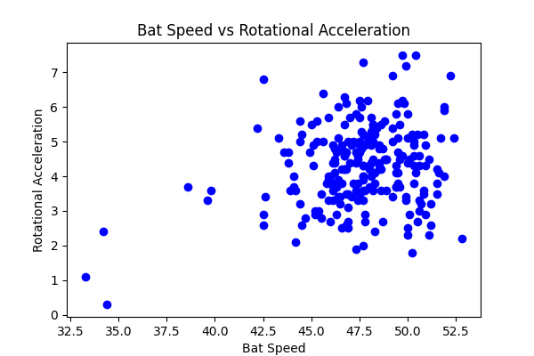

## Comments

Add comments here...